Title of the publication

K. Mustermann¹, D. Test², W. Lieschen-Müller¹
¹Institut A, Universität A, 10815 Irgendwo; ²Institut B, Universität B, 14711 Sonstwo
1. Introduction
Font: Arial 12; Justified; Line spacing 1.25

XXXXXXXXXXXXXXXXXXXXXXXXXXXXXXXXXXXXXXXXXXXXXXXXXXXXXXXXXXXXXXXXXXXXXXXXXXXXXXXXXXXXXXXXXXXXXXXXXXXXXXXXXXXXX.
2. Material and methods
2.1 Heading
XXXXXXXXXXXXXXXXXXXXXXXXXXXXXXXXXXXXXXXXXXXXXXXXXXXXXXXXXXXXXXXXXXXXXXXXXXXXXXXXXXXXXXXXXXXXXXXXXXXXXXXXX.
2.2 Heading
XXXXXXXXXXXXXXXXXXXXXXXXXXXXXXXXXXXXXXXXXXXXXXXXXXXXXXXXXXXXXXXXXXXXXXXXXXXXXXXXXXXXXXXXXXXXXXXXXXXXXXXXXXXXXX.
3. Results and Discussion
XXXXXXXXXXXXXXXXXXXXXXXXXXXXXXXXXXx

Write table headings above the table, in bold
Table 1: Prävalenzen ausgewählter tierbezogener Indikatoren
Indikator | n | 1. Erhebung  2015 | 2. Erhebung  2016 | 3. Erhebung  2017
 |  | X | X | X
BCS - stark verfettet | 30 | - | 0,9 % | 0,4 %
BCS – stark abgemagert | 30 | - | 2,0 % | 0,5 %
XXXXXXXXXXXXXXXXXXXXXXXXXXXXXXXXXXXXXXXXXXXXXXXXXXXXXXXXXXXXXXXXXXXXXXXXXXXXXXXXXXXXXXXXXXXXXXXXXXXXXXXXXXXXXXXX.

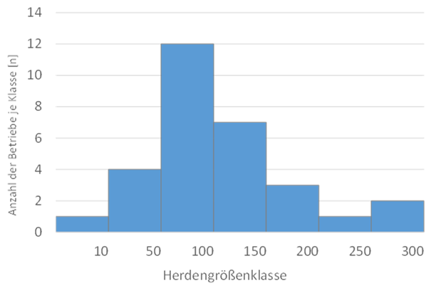
Figure 1: Verteilung der Herdengrößenklassen der untersuchten Milchziegenbetriebe (n=30) zur ersten Erhebung
Write a description of the illustration under the illustration, in bold

XXXXXXXXXXXXXXXXXXXXXXXXXXXXXXXXXXXXXXXXXXXXXXXXXXXXXXXXXXXXXXXXXXXXXXXXXXXXXXXXXXXXXXXXXXXXXXXXXXXXXXXXXXXXXXXXXXXXXXXXXXXXXXXXXXXXXXXXXXXXXXXXXXXX.

Table 2: Ergebnisse der QTL-Analysen in der Callipyge-Region des
Schweines

Merkmal | F-Wert¹⁾ | LOD | Additiv ²⁾ | Dominanz²⁾ | Imprinting²⁾
Speckdicke (Rückenmitte) | 2,86 | 1,857 | 0,033 ±0,014 | -0,031±0,020 | 0,009±0,017
- *: p<0.05, **:p<0,01; ²⁾ Effektschätzer ± Standardfehler.
4. Conclusion /Summary
XXXXXXXXXXXXXXXXXXXXXXXXXXXXXXXXXXXXXXXXXXXXXXXXXXXXXXXXXXXXXXXXXXXXXXXXXXXXXXXXXXXXXXXXXXXX.
References:
BLOKHUIS, H.J., I. VEISSIER, M. MIELE u. B. JONES 2010: The Welfare Quality® project and beyond: Safeguarding farm animal well-being. In: Acta Agriculturae Scandinavica, Section A — Animal Science, 60, S. 129–140.
COCHRAN, W.G. 1977: Sampling techniques. 3. Aufl. New York (= A Wiley publica-tion in applied statistics).
SPORKMANN, K. u. H. GEORG 2018: Leitfaden zur Bewertung des Tierwohls von Milchziegen. Braunschweig (Thünen Working Paper 108 https://doi.org/10.3220/WP1541073705000).
TIERSCHG 2006: Tierschutzgesetz in der Fassung der Bekanntmachung vom 18. Mai 2006 (BGBl. I S. 1206, 1313), das zuletzt durch Artikel 141 des Gesetzes vom 29. März 2017 (BGBl. I S. 626) geändert worden ist.

General information:
- Please use as little formatting as possible!
- Do not enter any separators manually (Word separates itself)
- Do not insert any text fields in tables or graphics. If so, then click on all fields and save as a graphic.
- Tables, graphics and photos must be labeled. If your contribution has many graphics, please contact us (info@dgfz-bonn.de). It is possible to send us the graphics individually in better resolution.
- Italics, capital letters, blocks and small caps may not be used.
- Language: German or English (Summary can be in both languages)

Only word files (doc or docx can be submitted. Please do not send PDF files.

Deadline for submitting the article: September 24th, 2020

The DGfZ reserves the right to reject contributions that do not meet the qualitative or formal requirements. Every contribution will be checked by us. Only your own contributions is allowed to be submitted.

